Skyler Jarman is young woman currently living in Omaha. She has a huge heart and lives for her pets. While she does enjoy designing homes and does have an education in doing so, she strives to further her education in art with graphic design. The following are some of the questions I was able to ask her:

Q: Describe yourself in one word.

Sky: I would say indecisive. It’s hard to experience everything if you can only make one choice, in a lot of cases.

Q: What do you think of garden gnomes?

Sky: They’re kind of cute, but also mysterious and full of secrets. I would never own one.

Q: What is your biggest pet peeve?

Sky: Chipped nails that snag on things. I put a lot of work into my nails, so it’s just very disappointing when that chip or crack.

Q: Do you consider yourself lucky?

Sky: Not lucky all the time, but I do have lucky things happen from time to time.

Q: What excites you?

Sky: Getting to come home after work. It is one of the greatest things seeing how excited my dog is to see me walk through that door. It fills my heart, for sure.

Q: If you could only smell three scents for the rest of your life, what would they be?

Sky: Clean laundry, coffee, and my own body odor so I can if I start to get stinky.

Q: You’ve been given an elephant that you can’t get rid of or sell, what would you do with it?

Sky: I would like to find a good organization to house it for me so I can come visit it and care for it. I don’t have near enough room for an elephant at my home.

Q: You found a lottery ticket and ended up winning $10 million. What would you do?

Sky: I would pay off dept, take out $100,000 for traveling and fun, and then put the rest into savings and investments with the help of a financial advisor.

Q: If you could compare yourself with any animal, which would you choose?

Sky: A cat.

Q: You are shipwrecked on a deserted Island, which three movies would you choose to have with you?

Sky: Spirited Away, About Time, and Fight Club.

Skyler loves caring for her German Shepherd named Philadelphia Collins and two cats named Cat and Rum Ham.

Style Guide

Wireframe

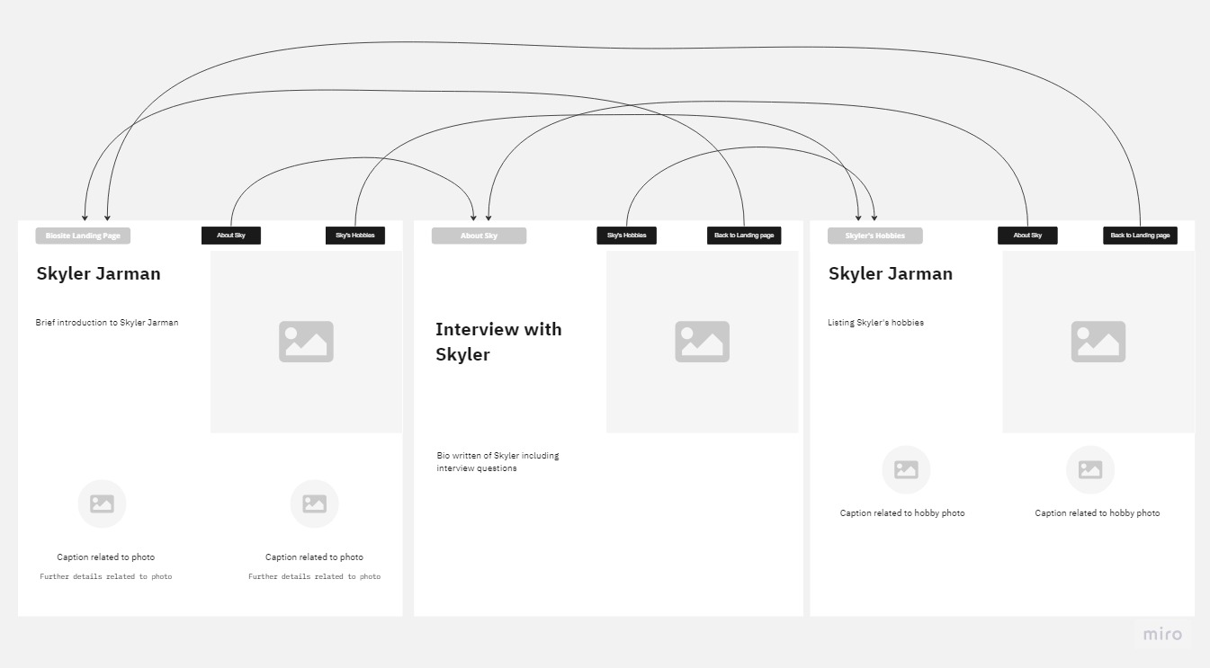

Photos